**FOR IMMEDIATE RELEASE**

BeInstrumental Foundation Donates 18 Instruments to Woodward High School's Band with Support from the Arts Commission of Toledo

Contact:

Jeff Green
President
jeff@beinstrumental.org

Toledo, Ohio – 2/1/24. BeInstrumental Foundation, a Toledo-based non-profit organization dedicated to providing enriching music experiences to underserved children in the community, is proud to announce a significant donation to Toledo Public School's Woodward High School band. Through the generous support of an ARPA grant awarded by the Arts Commission of Toledo, the City of Toledo and the Lucas County Commissioners, BeInstrumental has procured and refurbished 18 musical instruments, giving students at Woodward High School the opportunity to explore and grow their musical talents.

The donation includes a variety of instruments, carefully selected to meet the diverse needs of the high school's band program. Each instrument has been meticulously restored to ensure that students have access to high-quality equipment. This initiative is part of BeInstrumental's broader mission to ensure that all children, regardless of their socio-economic background, have the opportunity to experience the joy and benefits of music education.

"Music has the power to transform lives, and every child deserves the chance to experience that transformation," said Jeff Green, Co-Founder of BeInstrumental. "We are thrilled to support Woodward High School's band program and look forward to seeing how these instruments help inspire and elevate the musical journey of these talented students."

The ARPA grant, facilitated by the Arts Commission of Toledo, has been instrumental in enabling BeInstrumental to extend its reach and impact within the Toledo community. This collaboration reflects a shared commitment to nurturing the arts and supporting youth development through creative expression.

"We are deeply grateful for the support from BeInstrumental and the Arts Commission of Toledo," said Maggie Bittner, Assistant Band Director at Woodward High School. "These instruments are a game-changer for our program, allowing us to provide a more inclusive and enriching band experience for our students. We can't wait to see the joy and growth that comes from this generous donation."

The BeInstrumental Foundation remains committed to breaking down barriers to music education and is excited to continue its partnership with local schools, organizations, and the community to foster a love of music in young hearts across Toledo.

For more information about BeInstrumental and its programs, or to learn how you can support their mission, please visit www.beinstrumental.org.

About BeInstrumental Foundation

BeInstrumental Foundation is a non-profit organization based in Toledo, Ohio, dedicated to providing underserved children with opportunities to learn, play, and enjoy music. Through donations, grants, and community partnerships, BeInstrumental supports music education programs, provides instruments to those in need, and advocates for the importance of arts in education.

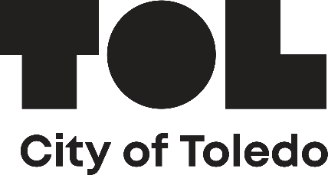

**END**

